**Inkjet Printing Operation**

1. Turn on printer with switch (gif)

2. Open Dimatix Drop Manager (gif)

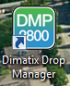

3. Click “Yes” when asked “Load the currently selected cartridge settings (Dimatix Model Fluid Settings)?”

* This is one point where you can change the cartridge settings. If you need to change the settings click “No” and load one of the saved settings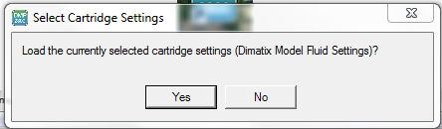

4. Select a Pattern to print

* Click “select” on the pattern tab (select pattern gif)
* Load a saved pattern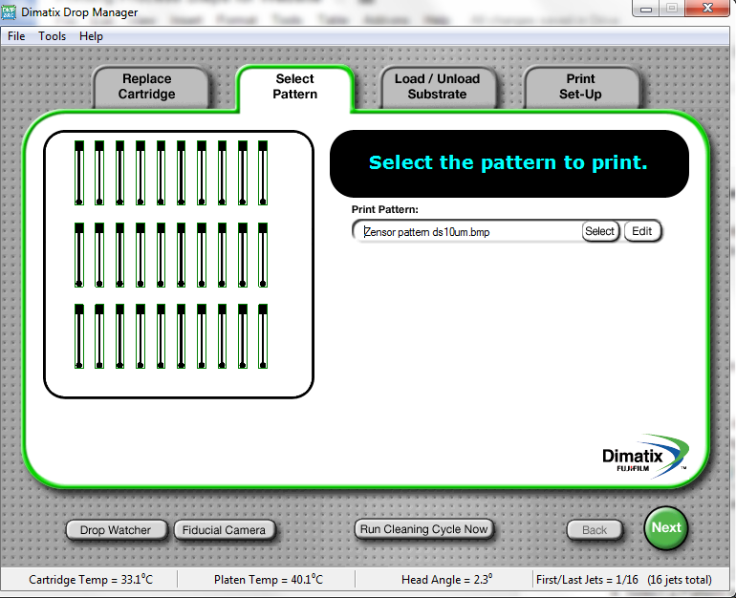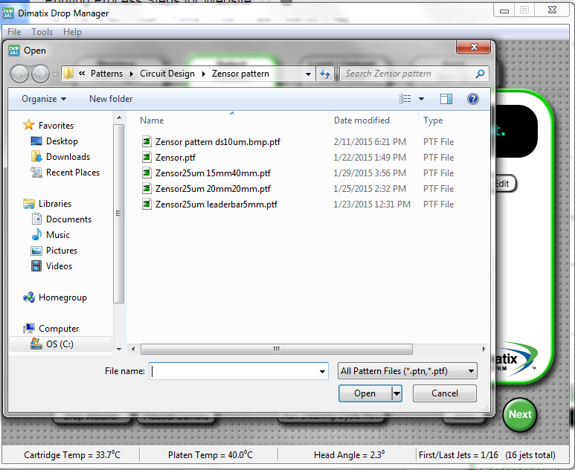
* Click “Next”to take you to the “Load/Unload Substrate” tab

5. In the “Load/Unload Substrate” tab you can change the substrate thickness settings and the substrate temperature

* Change the thickness setting to your best estimate of the substrate thickness and change the temperature by using the arrows or entering the number manually. (temperature thickness gif)

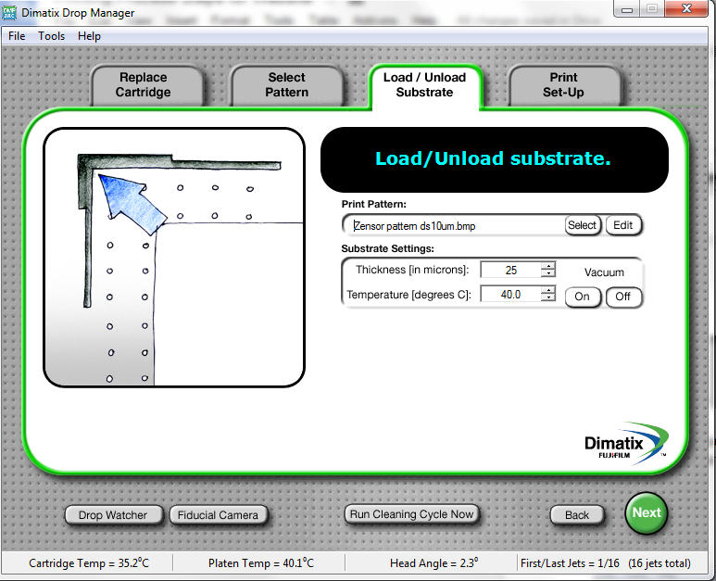

* Click “Next”to take you to the “Print Set-Up” tab

6. The “Print Set-Up” tab is another place to change the cartridge settings (generally doesn’t need to be modified).

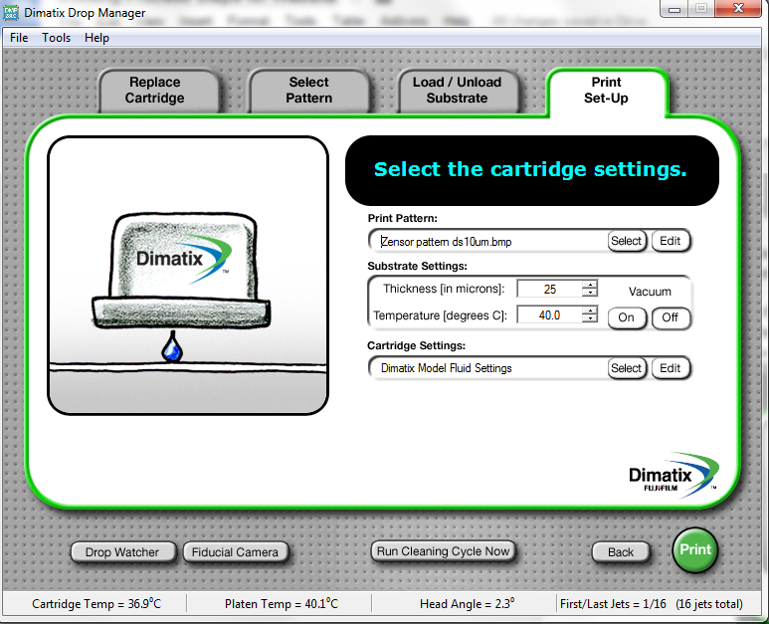

* Click “Select” on the Cartridge Settings bar (cartridge settings gif)
* Load saved settings

7. Click “Print” to preview the pattern to be printed, then press “Print” on the window that pops up.

Loading The Cartridge

1. Select a new cartridge from the cartridge box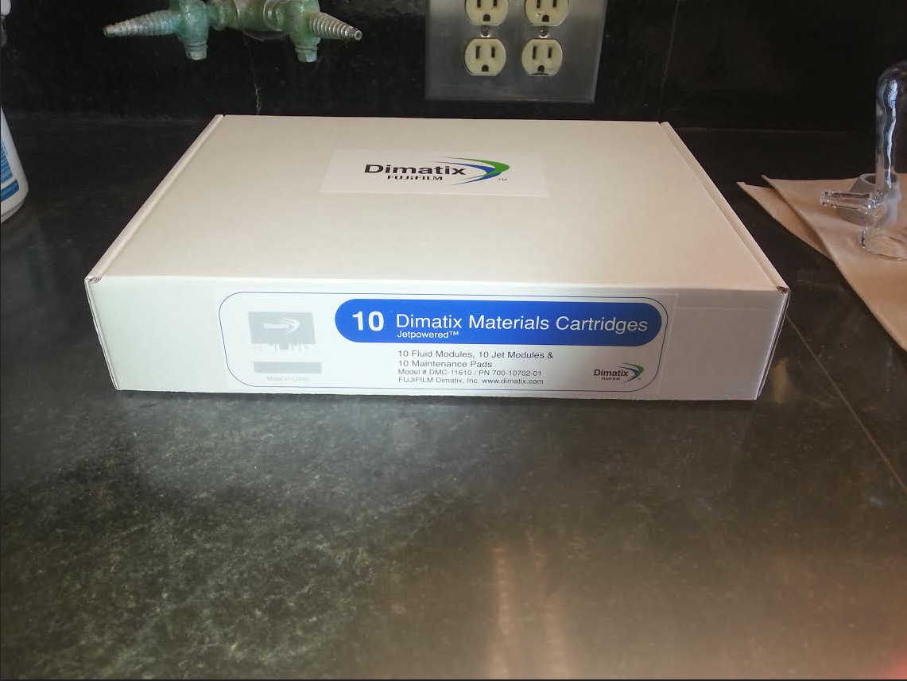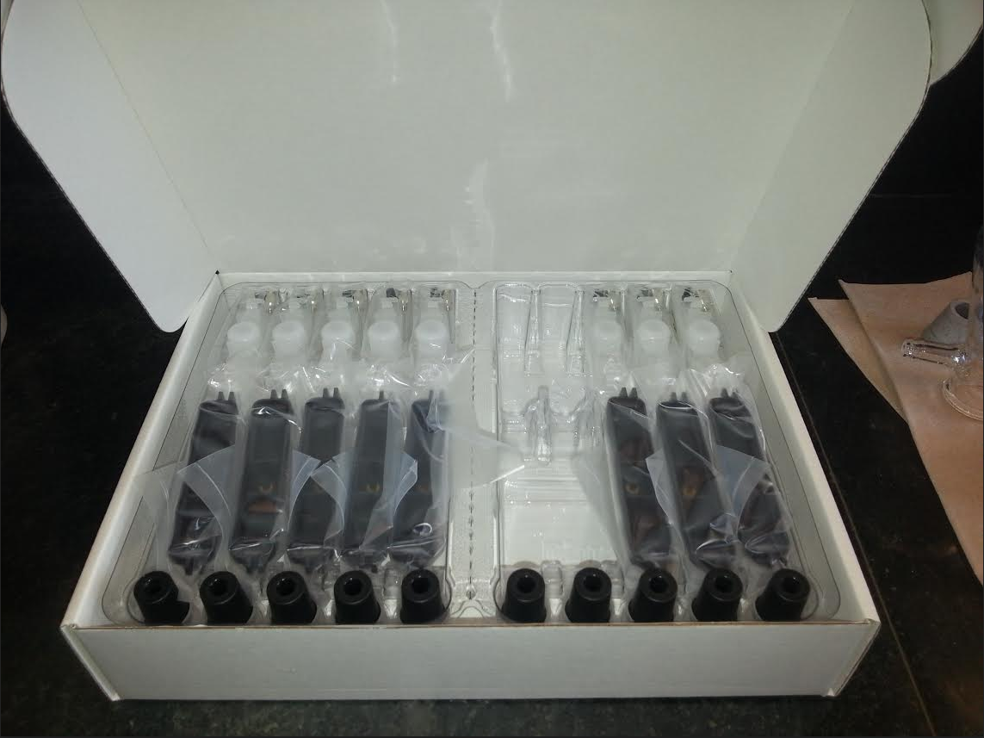
2. Open the bag with the transparent piece and the bag with the black piece.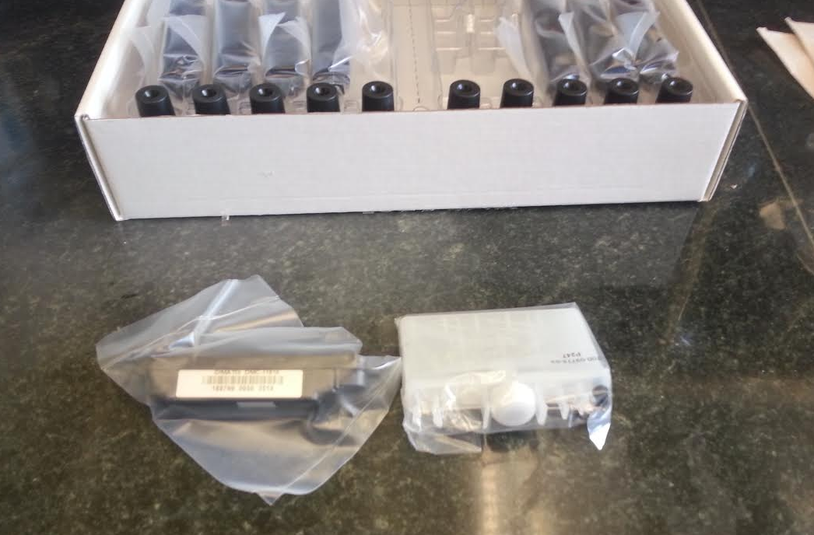
3. Unscrew the white cap on the transparent piece.
4. Fill the transparent piece with ink (gif)
5. Snap the black piece to the transparent piece (gif)
6. Load the cartridge into the cartridge slot on the printer.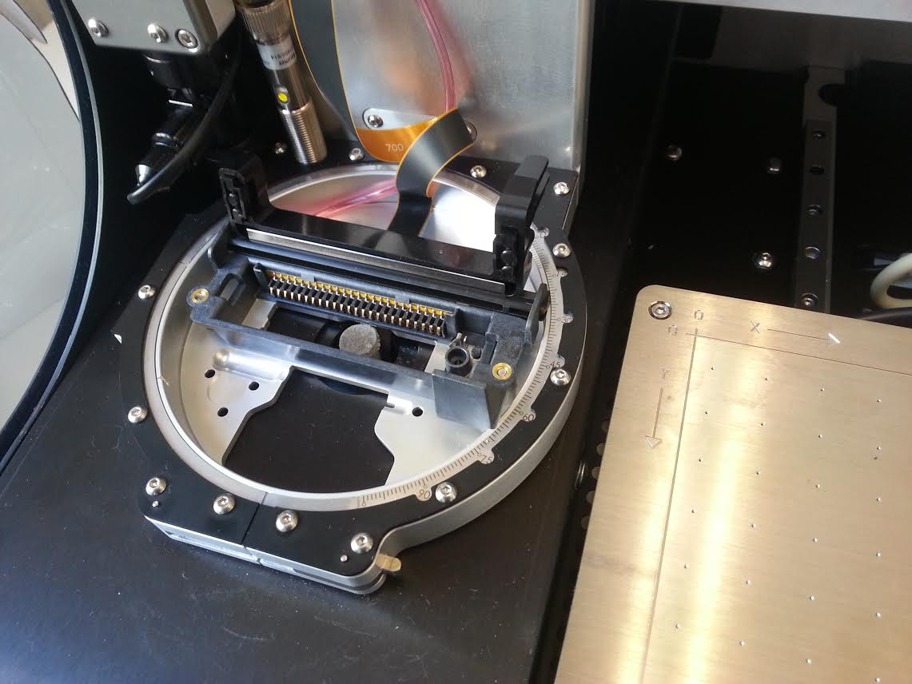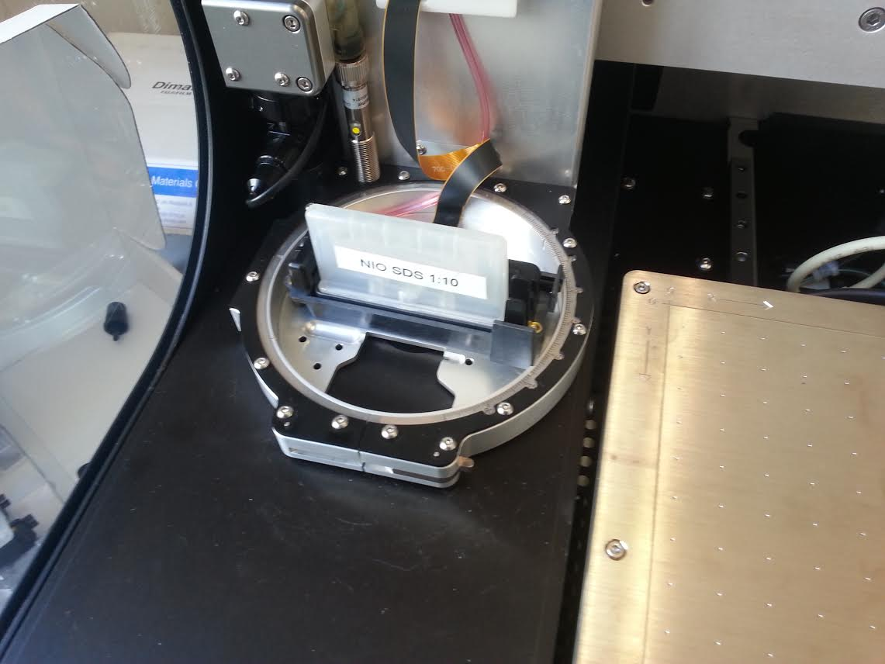
7. Shut the printer hatch

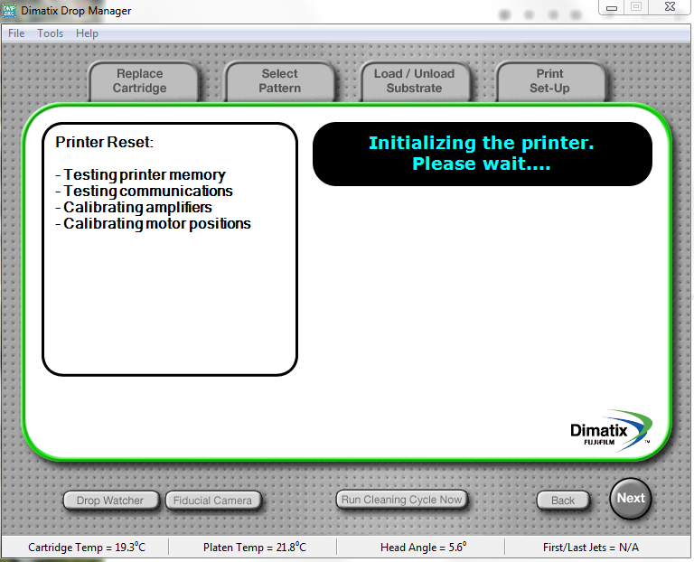

* Load the printer with the desired cartridge. (gif)
  + Link to cartridge preparation should be included.
* Select awesome pattern. (gif)
  + How to create patterns
  + How to use drop watcher and Fiducial Camera
* Load and Unload substrate (gif)
  + Taping substrate to platen helps!!
* Print Vader.

How to use fiducial camera

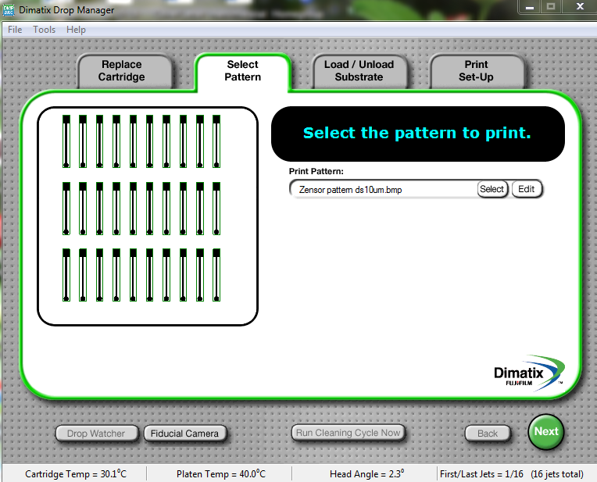

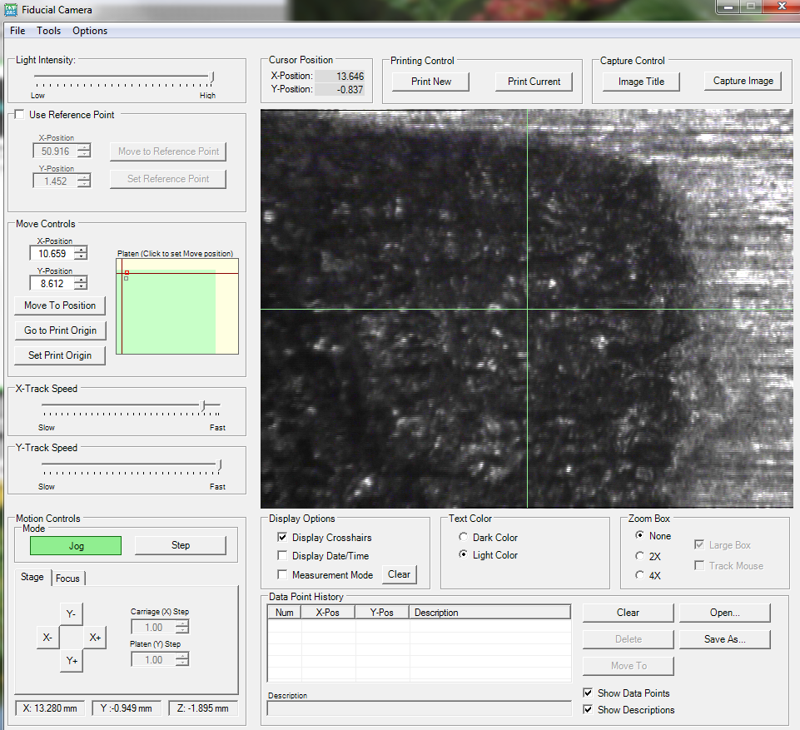

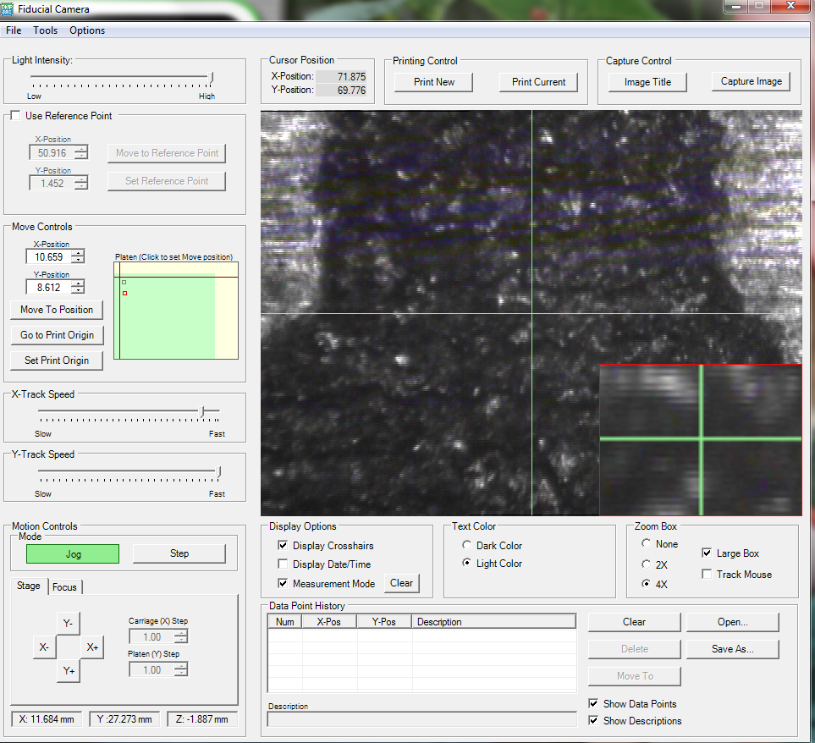

How to use drop watcher